Running Test from the Console

 Configuring the Junit-4 version from the eclipse build path to add libraries

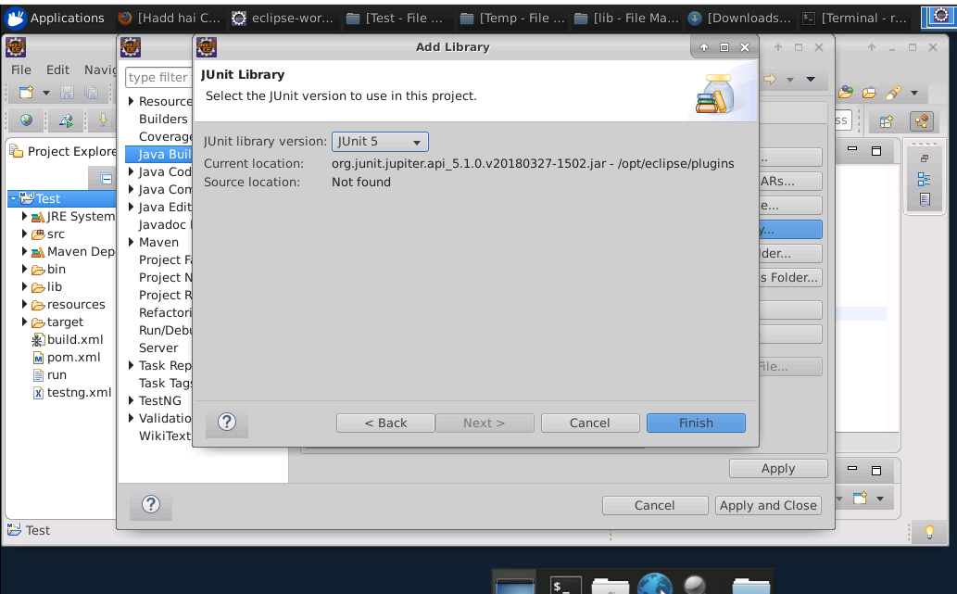

1. Make sure there is no error in the script.
2. Open the command prompt and set the path folder where you saved the JavaScript file.
3. To compile the Java file, write the command given below:

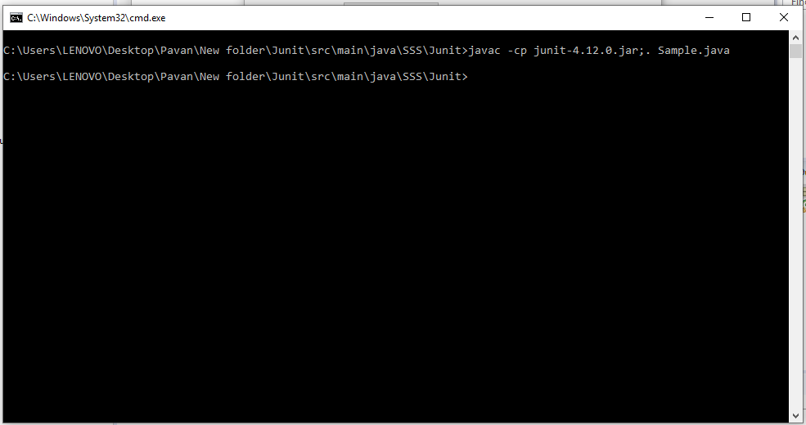

1. Run the Junit java file in the command prompt.

Type the command: *javac -cp junit-4.12.jar;. UserDAOTest.java*

Type the command: *java -cp junit-4.12.jar;hamcrest-core-1.3.jar;. org.junit.runner.JUnitCore UserDAOTest JUnit version 4.12*